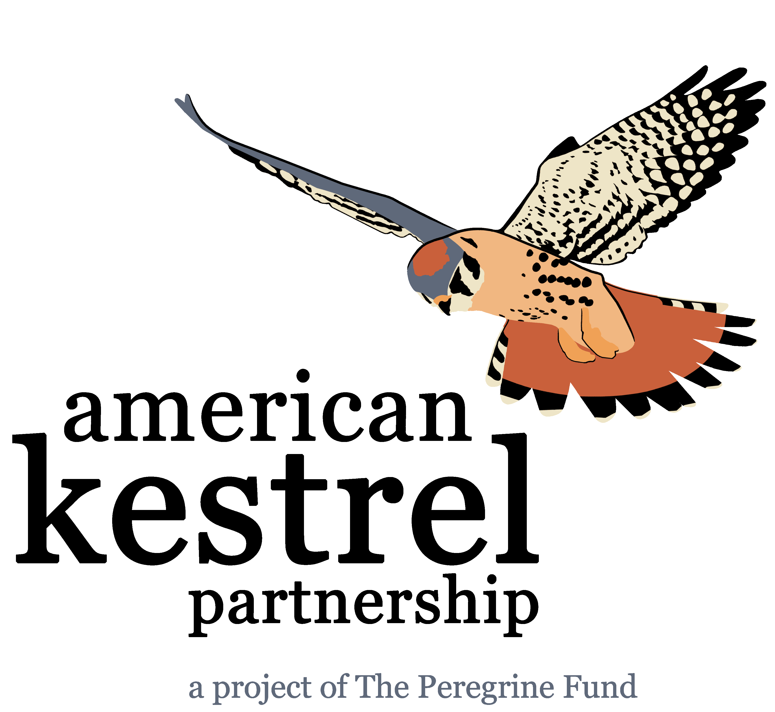
“Month (spelled in full)” “Day” “201x”

“Local business name”
“Street address”
“City”, “State”, “Zip code”

Dear “business name”:

The “organization name” is participating in an exciting new research and conservation program called the American Kestrel Partnership, coordinated by The Peregrine Fund, an international non-profit organization committed to the conservation of birds of prey worldwide. The American Kestrel is North America’s smallest and most colorful falcon. Unfortunately, kestrel populations are declining across many regions of North America. As a participant in the Partnership, the “organization name” is building and installing nest boxes locally to provide breeding habitat for this cavity nesting species. In addition to building nest boxes, we are periodically monitoring the boxes to collect data for the Partnership’s research program.

As a partner in this new program, the “organization name” is interested in having “business name” provide local sponsorship of the American Kestrel Partnership via discounted or donated materials for building nest boxes. We are proposing to build “#” nest boxes (see attached materials list), for which we are seeking sponsorship by “business name” via discounted or donated materials. In addition, the “organization name” will recognize “business name” in all local education presentations and media productions.

Thank you for your time and consideration.

Sincerely,

“Space for signature”

“Name”
“Organization name”
“Street address”
“City”, “State”, “Zip code”
“Phone number”
“Email address”

